* Upgrade mail core by Ms. Tham
* check mail core version [new server]

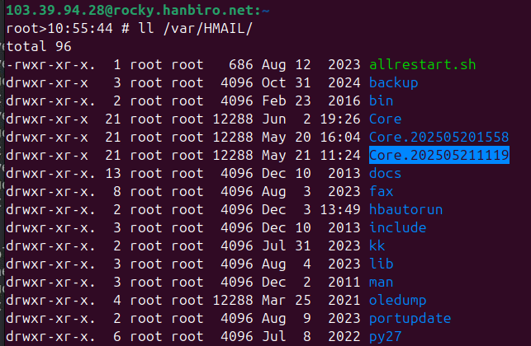

* Check hb_grpc_middleware process on old server:

# stat /var/HMAIL/Core/golang/hb_grpc_middleware

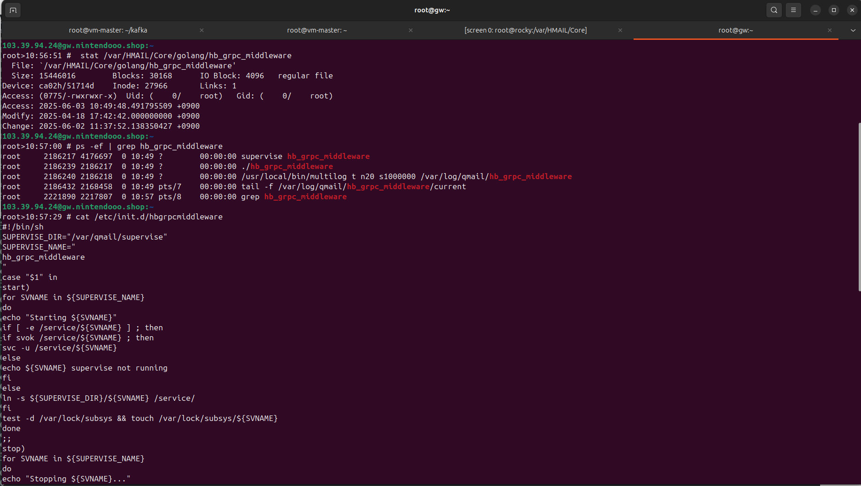

* resync mail: 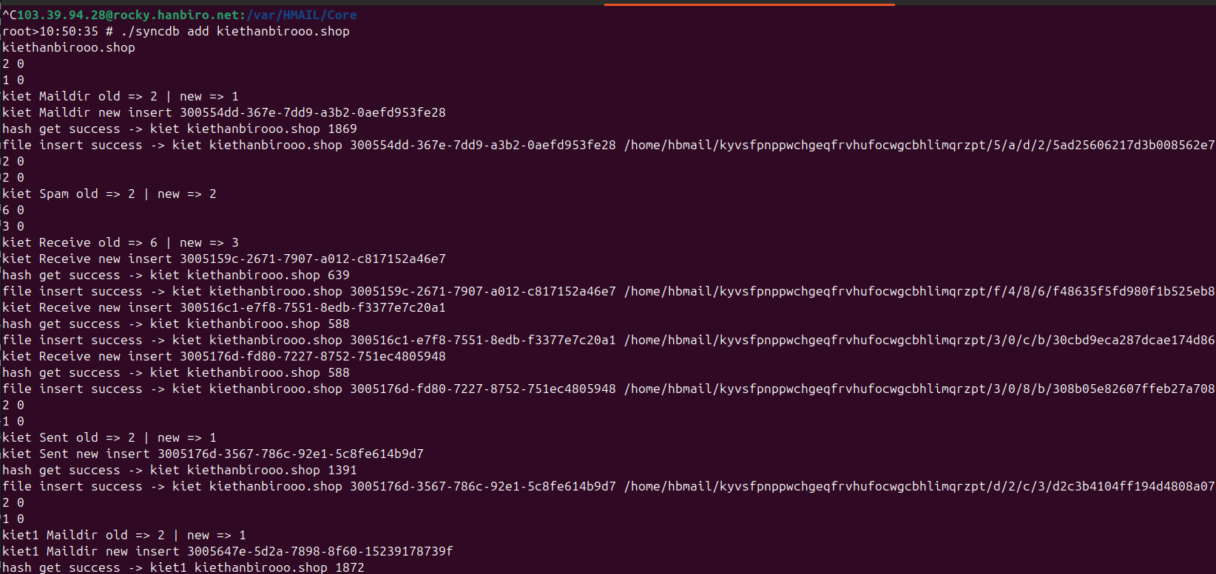
* check mail on new server:

